1. Purpose 3
2. Audience 3
3. Concept 3
4. Use Cases 3
4.1 Open Collection 4
4.1.1. User Browses Collections via PAH’s UI. 4
4.1.2. Current Collection and/or Project Closes. 4
4.1.3. Default Project Loads. 4
4.1.4. UI Updates. 4
4.2 Close Collection 4
4.2.1. Collection with no changes. 4
4.2.2. Collection with changes. 4
4.2.3. UI Updated. 5
4.3 Open Project. 5
4.3.1. Collection or User Defined Project. 5
4.3.2. Current Project or Collection closed. 5
4.3.3. Project is loaded into Workspace. 5
4.3.4. UI Updates. 5
4.4 Edit Project. 5
4.4.1. User edits project as desired. 5
4.4.2. User navigates back and forth between open projects. 5
4.4.3. Edits pending until project saved. 5
4.5 Close Project 5
4.5.1. Collection Project 6
4.5.2. User Defined Project 6
4.6 Use of Art Assets 6
4.7 Keyword Search 6
4.7.1. User specifies search criterion 6
4.7.2. User views search results 7
4.7.3. User may open item in search results. 7
4.8 New Purchases 7
4.8.1. User purchase new item (collection, project or art asset) 7
4.8.2. Purchase transaction. 7
5. Native Collection Constructs 8
5.1 Collections 8
5.2 Elements of a Collection 8
5.3 Collection Repository 8
5.4 Collection Manifest 8
6. Collection Management Component 9

Purpose
The purpose of this document is to provide a tentative specification for Print At Home’s (PAH) Content Collection requirement. It specifies how content collections are managed from the application perspective.

Audience
This document is primarily of interest to developers with tasks tied to the content collection and perhaps content management personnel that are responsible for merchandising collections.

Concept
PAH is a printing application comparable to Create and Print (CnP). However, instead of limiting the user to one project PAH provides the capability to manage collections of projects (i.e. cards). The user may navigate to various native (local to user’s PC) collections, view individual projects and art assets associated with a collection. For example, a wedding collection might be composed of invitations, RSVP cards and so on. An art asset might be a lone flower that may be replicated on a number of projects within a collection. Note that art assets are independent of images that appear on the invitation. The art asset would be of appropriate resolution and devoid of effects such as shadowing which may be appropriate within the context of the card but not as an individual piece of art. The purpose of these art assets is to facilitate ease of reuse by the user.

Composition of the collection is determined by Content Management via PDB. A collection contains one or more projects and may contain one or more art assets. A PAH project is a composition of content such as images and text that is created with the PAH application. Each project and art asset in collection is defined by various attributes such as Product ID, Title, Thumbnail, Thumbnail size, Sequence Identifier, Occasion, Theme, keyword search string and so on. The project attributes are used in the rendering of UI and native collection management.

Use Cases
The following is a generic description of user scenarios that impact the design and implementation of content collection related tasks. The purpose is to highlight the requirements related to content collection. They contain only the detail necessary to convey the pertinent actions and constraints involved. Other closely related uses cases can be inferred from the ones described here such as: “Save”, “Save As” and so on.

Open Collection
User may open a collection at anytime. Note that application validates collection to ensure that user has owner rights to open.

User Browses Collections via PAH’s UI.
Only collections installed locally, those packaged with the app or purchased at a subsequent date. The users can select only one collection at a time.

Current Collection and/or Project Closes.
If a collection is already loaded, including projects and art assets, it is closed completely. The user is prompted to save any changes.

Default Project Loads.
The workspace is loaded with the first project in the collection. Project sequence within a collection is determined by the Sequence Identifier attribute.

UI Updates.
All applicable views reflect current collection. All applicable UI controls are enabled. User can navigate to all projects within a collection.
All open Add-ins (i.e. Image Editor) are updated to reflect the load of new collection.

Close Collection
User may close an entire collection at anytime.

Collection with no changes.
Collection and all its projects are closed; no prompts are presented to user.

Collection with changes.

- User is prompted to save/cancel changes for each project that has changed.

- Projects that are a part of PAH merchandised collection are read only.

- If save selected, users are required to specify a new file name. The user can specify a relative path but NOT absolute one. For example, “\My Wedding\Invitations.pah”

- The project is saved in a standard root location known to PAH with the user specified filename and the PAH file type. This simplifies content navigation and security.

UI Updated.
Workspace is cleared and UI reflects empty state. For example, project navigation controls may be disabled.

Open Project.
The user is not limited to working with an entire collection at a given time. The user may chose to open a single project.

Collection or User Defined Project.
The user may browse native collections and choose to open one of its projects (i.e. greeting card) or to re-open a project that has been modified and saved by the user.

Current Project or Collection closed.

- If a collection already opened it is closed completely including project and art assets. The user is prompted to save/cancel any changes.

- I f a project is opened it is closed and user is prompted to save/cancel changes.

Project is loaded into Workspace.

UI Updates.
For example, new project reflected in navigation (i.e. Carousel Control).

Edit Project.

User edits project as desired.

User navigates back and forth between open projects.

Edits pending until project saved.

Close Project
A project can be closed by user at anytime.

Collection Project
User has the option of closing individual projects that are a part of an open collection. For example, user may close/save Invitation while still working on RSVP card.

- User prompted to save/cancel changes for this project only.

- Next project in collection sequence comes into view, appears in Workspace. If there are no other projects then Workspace is empty.

- Other projects loaded with collection remain loaded and unchanged.

User Defined Project
A user defined project is a project that does not belong to a collection, it is one that has been modified and saved by the user.

- User prompted to save/cancel changes for this project.
- Workspace is emptied.

Use of Art Assets
An art asset is either a vector or raster image. The art asset is typically replicated in another composite project such as a greeting card but yet it is completely independent. The image is typically of higher resolution then its replica, the purpose is to provide user utility and versatility.

- Art assets can NOT be opened into the Workspace as individual projects. In other words, art asset can only augment existing projects.

- Image editing is primarily through the Image Editor.

Keyword Search
Keyword search provides the user with the capability to search for collections, projects and art assets by a descriptive keyword.

User specifies search criterion
User specifies keyword string and filter. For example, user may search for “hearts” and filter by “Art” or “Collections” or “Projects” or “All”.

User views search results
- The keyword attribute associated with native projects and art assets are fed into search algorithm.

- Title, thumb nail and other attributes are used to render search results.

User may open item in search results.
- The open behavior is the same as described in previous “Open” scenarios.

- User may only open collections and projects – art assets are excluded.

New Purchases
User may at anytime purchase new collections, projects or art assets. Purchased items are downloaded to user’s PC.

User purchase new item (collection, project or art asset)
- Must be online.
- Must have PAH app.
- Manifest-like file dynamically created on server. Reflects purchased items and associated attributes.
- Merchandise is tied to owner. For example, other PAH users cannot copy and reuse.

Purchase transaction.
- User may purchase multiple collections via web shopping cart.
- Manifest (i.e. XML file) is downloaded to user after transaction complete.
- Manifest file contains all merchandise info.
- Server instantiates app component and passes it the manifest.
- App validates manifest file. For example, ensures correct schema.
- Collection, project, art assets and thumbnails are NOT downloaded yet. The reason for this is because only the app knows where to store files and it is also more conducive to a seamless user experience.

- PAH app is signaled to process manifest.
- PAH app pulls-down items.
- Manifest specifies location of downloads.
- App downloads and updates native collection repository.
  - App is signaled that repository has changed and app UI is updated.

Native Collection Constructs
The following is the specification for native content management. It is derived from the behavior outlined by the use cases above.

Collections
A collection contains individual projects and art assets. Each collection has attributes such as a unique identifier, title, thumbnail, thumbnail size, Sequence Identifier, Occasion, Theme and keyword search string. Note that collections can be grouped under multiple categories.

Elements of a Collection
Elements that make up a collection can be either a project (PAH project) or art asset (image file - JPEG, BMP, GIF…). Elements have a unique identifier (Product Id), Title, Thumbnail, Thumbnail size, Sequence Identifier and keyword search string.

Collection Repository
The collection Repository is a local file/directory structure that houses all purchased collections. It contains all data necessary to perform local collection management and UI tasks. It captures the parent-child relationship between a collection and its individual elements (projects and art asset). A native manifest file is maintained to capture in totality of all PAH merchandise purchased by user. For example, this manifest file is used as input into the keyword search algorithm.

Collection Manifest
The Collection Manifest is an XML file that captures the relationship between collections and its content. The Figure 5.4.1 is a first stab at a Manifest schema. It will, more than likely, change as requirements solidify but it is useful for facilitating a discussion.

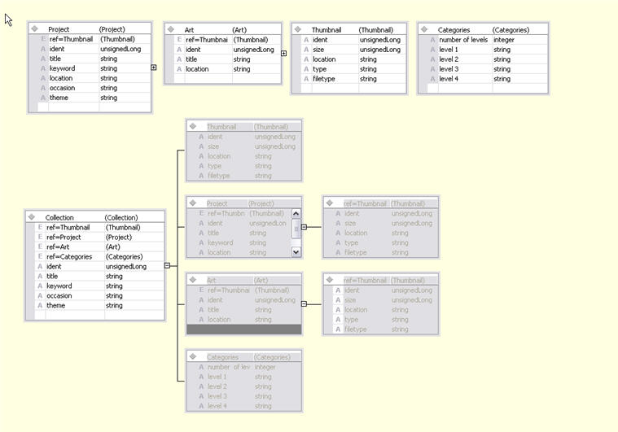

Figure 5.4.1

Collection Management Component
The Collection Management component is a part of the PAH application. It is responsible for managing the native collection repository and it also exposes an interface to support purchase transactions.

